**Name:**

Haleema Binte Jamil

**Registration No.:**

FA20-BSE-005

**Department:**

Computer Science

**Bachelor’s In:**

Software Engineering

**Semester:**

7th

**Section:**

A

**Subject:**

Design Patterns

**Topic:**

Assignment 1

**Submitted To:**

Sir Mukhtiar Zamin

**Submission Date:**

26/10/2023

**Assignment 1**

**Hotel Management System:**

Make a class diagram for a chain of hotels management system using;

* Observer pattern for real time communication
* Template pattern for complaint resolution
* Builder pattern for meal preparation
* Strategy pattern for Feedback on service quality

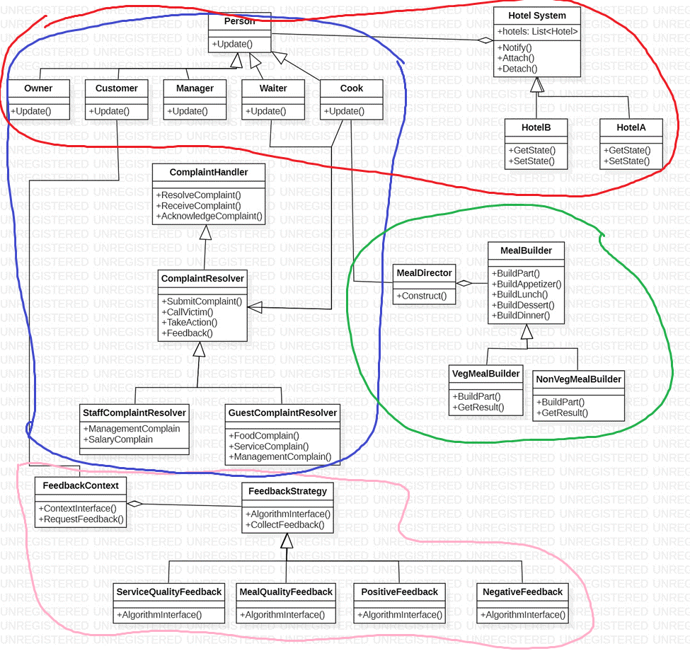

**Red: Observer, Blue: Template, Green: Builder, Pink: Strategy**